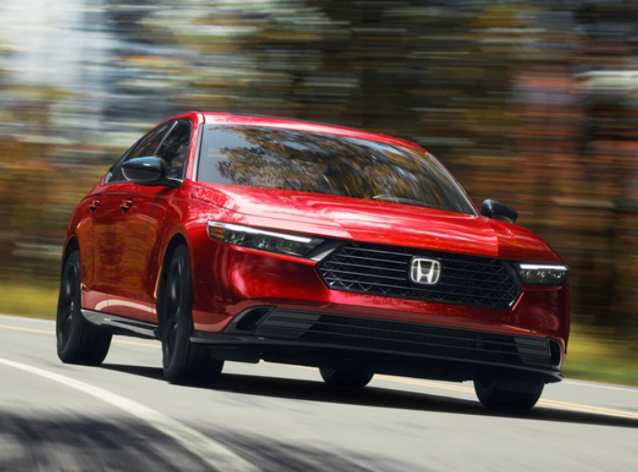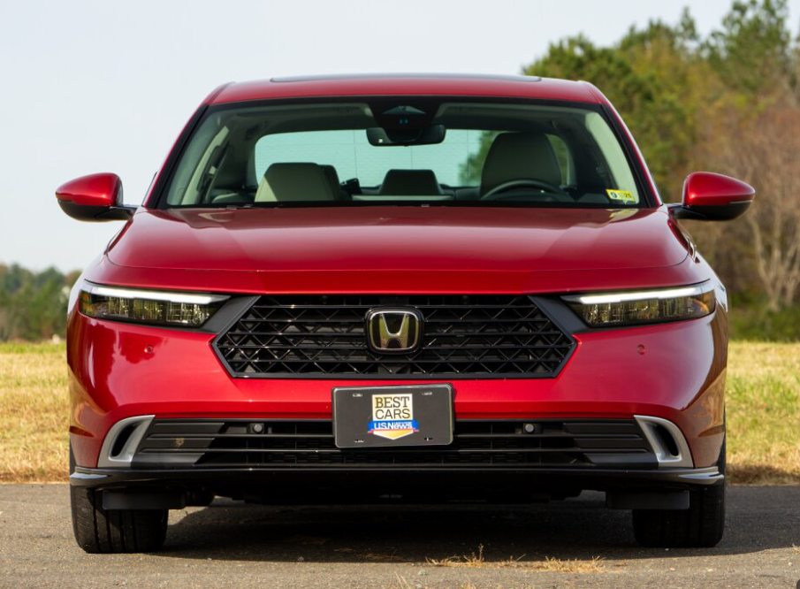

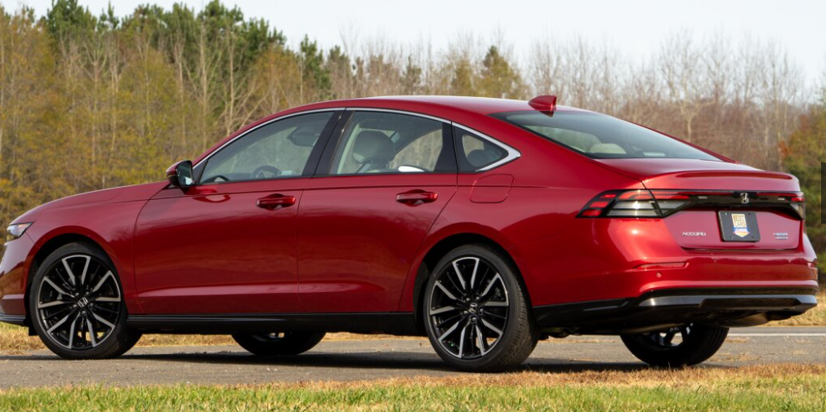

**Main specifications** for the **2025 Honda Accord** (11th generation)

**🔋 Powertrain**

* **Hybrid-only lineup** featuring:
  + 2.0 L inline‑4 petrol (108 kW) + electric motor (135 kW / 335 Nm) → **152 kW total** (~204 hp) No gas‑only or V6 options offered
* **Transmission**: e‑CVT (Honda’s i‑MMD hybrid system)
* **⛽ Fuel Efficiency & Performance**
* **Fuel consumption**:
  + ~4.3 L/100 km (~55 mpg US) in combined driving
* **Acceleration**: 0–100 km/h (0–62 mph) in ~7.3 s

**📏 Dimensions & Capacity**

* **Length**: 4,971 mm (195.7 in)
* **Width**: 1,862 mm (73.3 in)
* **Height**: 1,450 mm (57.1 in)
* **Wheelbase**: 2,830 mm (111.4 in) **Curb weight**: ~1,469 kg (3,239 lb)
* **Cargo space**: ~473 L (16.7 cu ft) trunk **🖥 Interior & Technology**
* **Infotainment**: 12.3″ touchscreen running Android Automotive OS + digital instrument cluster + head‑up display
* **Comfort & Convenience**: Leather seats, Bose premium audio, wireless phone charging, digital key **🛡**
* **Safety & Driver‑Assist**
* **Honda Sensing®** standard:  
  Adaptive cruise control, lane keep assist, collision mitigation, traffic sign recognition, blind‑spot monitor, rear cross‑traffic alert, driver monitoring, 360° camera

**🏁 Chassis & Handling**

* **Suspension**: Front MacPherson strut, rear multi‑link setup Designed for luxury‑level comfort with refined NVH insulation, noise-cancellation tech, and tech‑tuned ride quality

**📌 Summary Table**

| **Spec Category** | **Details** |
| --- | --- |
| **Powertrain** | 2.0 L Hybrid (204 hp) |
| **Transmission** | e‑CVT (i‑MMD) |
| **Fuel Economy** | ~4.3 L/100 km (~55 mpg US) |
| **0–60 mph** | ~7.3 s |
| **Length / Width / Height** | 4,971 mm / 1,862 mm / 1,450 mm |
| **Wheelbase** | 2,830 mm |
| **Curb Weight** | ~1,469 kg |
| **Trunk Capacity** | 473 L (16.7 cu ft) |
| **Infotainment** | 12.3″ screen, Android Auto/AOSP integration |
| **Safety** | Full Honda Sensing suite |
| **Comfort** | Leather, Bose audio, wireless charging |
| **Suspension** | Independent front & rear |